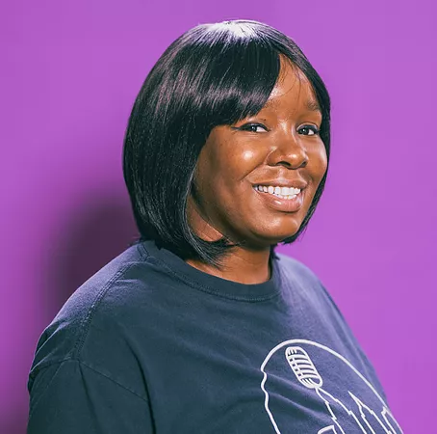 |  | Marla Eyvette massie  Comedian | Producer | Activist
BIO  Marla Eyvette Massie is a standup comedian, actress, writer, and producer of the Sixth City Comedy Festival in Cleveland, OH. Heavily influenced by sketch comedy, improv, and late-night talk shows, Marla's quick wit, self-deprecating humor, and clever wordplay makes her views on family, motherhood, and everyday life entertaining and thought-provoking.  She performs in festivals and clubs all over the country, and has worked with Franqi French, Mary Santora, Curtis Cook, and Shane Torres.  In February 2021, she was a panelist on "Room For Discussion: Mentorship & Black Women in Comedy", as part of a joint collaboration with Facebook Messenger and Variety Magazine.  Marla is currently writing a sketch comedy show to be released on YouTube.  Contact  WEBSITE:  www.SixthCityComedy.com  EMAIL:  Marla@SixthCityComedy.com  social media  @MarleyFromCLE on all social media |  | club appearances  HARVEY’S COMEDY CLUB (PORTLAND, OR)  HELIUM COMEDY CLUB (PORTLAND, OR)  COMEDY WORKS (DENVER, CO)  FT. WAYNE COMEDY CLUB (FT. WAYNE, IN)  WILEY’S COMEDY CLUB (DAYTON, OH)  HILARITIES/PICKWICK & FROLIC (CLEVELAND, OH)  FUNNY STOP COMEDY CLUB (CUYAHOGA FALLS, OH)  THE COMEDY STUDIO (SOMERVILLE, MA)  STANDUP NY (NYC)  NEW YORK COMEDY CLUB (NYC)  WEST SIDE COMEDY CLUB (NYC)  BROOKLYN HOUSE OF COMEDY (NYC)  GREENWICH VILLAGE COMEDY CLUB (NYC)  FESTIVAL appeArances  SALEM COMEDY & SPIRITS FESTIVAL (SALEM, MA) (2019)  CLEVELAND COMEDY FESTIVAL (CLEVELAND, OH) (2019, 2020)  WOOTENANNY COMEDY FESTIVAL (WORCESTER, MA) (2019)  MAUMEE, MARY, & JOSEPH COMEDY FESTIVAL (FT. WAYNE, IN) (2019)  NW BLACK COMEDY FESTIVAL (PORTLAND, OR) (2018-2022)  SIXTH CITY COMEDY FESTIVAL (CLEVELAND, OH) (2021-CURRENT)  MUTINY RADIO COMEDY FESTIVAL (SAN FRANCISCO, CA) (2021)  AWARDS  CLEVELAND SCENE MAGAZINE: BEST LOCAL COMEDIAN (FEMALE)—3RD PLACE (2019)  NOTES  PRODUCER: SIXTH CITY COMEDY FESTIVAL (CLEVELAND, OH)  CONTENT WRITER: WHOHAHA  CONTENT WRITER: BLACK GIRL MEDIA

